Software Requirements Specification

For

PATRONUS

Version 1.0 approved

Prepared by: Team –PATRONS

PATRONUS

20th March, 2018
Table of Contents
Table of Contents ii
1. Introduction 1
1.1 Purpose 1
1.2 Document Conventions 1
1.3 Intended Audience and Reading Suggestions 1
1.4 Product Scope 1
2. Overall Description 2
2.1 Product Perspective 2
2.2 Product Features 2
2.3 User Characteristics 3
2.4 Operating Environment 3
2.5 Design and Implementation Constraints 3
2.6 Assumptions and Dependencies 3
3. External Interface Requirements 4
3.1 User Interfaces 4
3.2 Hardware Interfaces 4
3.3 Software Interfaces 4
3.4 Communications Interfaces 4
4. System Guide 5
5. Other Nonfunctional Requirements 6
5.1 Performance Requirements 6

Introduction

Purpose
- Patronus is a system that is designed to provide its users full power safeguard security.
- It gives user to roam freely without any kind of security tensions.
- If there are robbers (if any) at user’s house then user will get notified and company will provide the complete security service.
- This document is used to describe and track the software requirements for home security system. This will describe the external interface requirements, non-functional requirements and overall description, system features, etc.

Document Conventions
This document is created based on the IEEE template for System Requirement Specification Documents.

Main Section Title:
Font: Arial Face: Bold Size: 32

Sub-Section Title:
Font: Times Face: Bold Size: 18

Other Text Explanation:
Font: Times Face: Normal Size: 11

Intended Audience and Reading Suggestions
Anyone can use Patronus because who doesn’t want a tension free life while travelling or working. This SRS is useful for developer, user, external guide and international guide. Each of them can easily understand how to use our software product by reading this SRS.

Product Scope
- Protonus is for the students who live in flats and have a daily busy college schedule.
- The document addresses the general purpose for home security system. Any detailed requirement can be verified with the user or the customer.

Overall Description

Product Perspective

Patronus is all new, self contained product and service. The system class diagram is as follows:

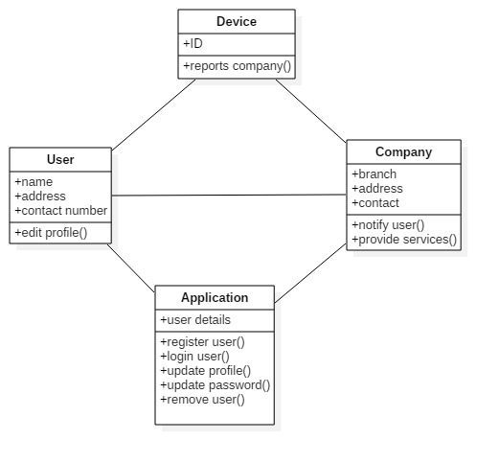

Product Features
- Can be placed anywhere as it is mobile.
- No police involved, as we will send our own security team.
- Therefore no more FIR
- Quick action will be taken.

User Characteristics
Passwords:
- Many users, security specialists and administrators rely at least in part on passwords to authenticate the identity of those who wish to gain access to the security system.
- Passwords need to incorporate more than just letters for the greater security, making use of numbers and other symbols on the keyboard.
- So, those wishing to gain access by defeating password key can not do so.

Operating Environment
In our system, we would be using following software and hardware:
- Hardware:
- Arduino Uno
- GSM 900A module
- Software:
- SQL server (2005/2008)
- Android OS(minimum requirement android 4.4 kit-kat)

Design and Implementation Constraints
- Performance may depend on the network traffic
- Static charge may damage the GSM module
- Any careless measure taken during installation may cause the system to not work at all
- Although we strive to dispatch the response team as soon as possible, conditions like traffic and other factors may affect the response time

Assumptions and Dependencies
- The SIM card used has enough balance to make an SMS
- Network is strong in that area
- Enough power supply is supplied
- Clear or minimum traffic for best response time
- Cellular phone that gets the updates on situation
- If using android app, the minimum requirement is android 4.4(Kit-Kat)

External Interface Requirements

User Interfaces
The android app lets user to create an account for himself which contains information like Phone Number to which the notifications will be sent, the location of the house etc. The app also allows user to change the information as required by the user.

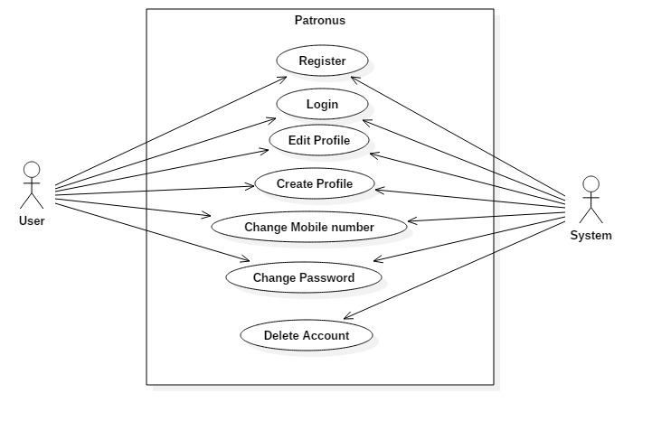

Software Interface
Patronus has its own android application where user registers itself and the data is stored in database of company. So, mainly it only requires an android phone to use the system.

Hardware Interfaces
The device sends location of the house where the burglary occurred, in triangulated format which is then converted to human readable format for the response team.

System Guide

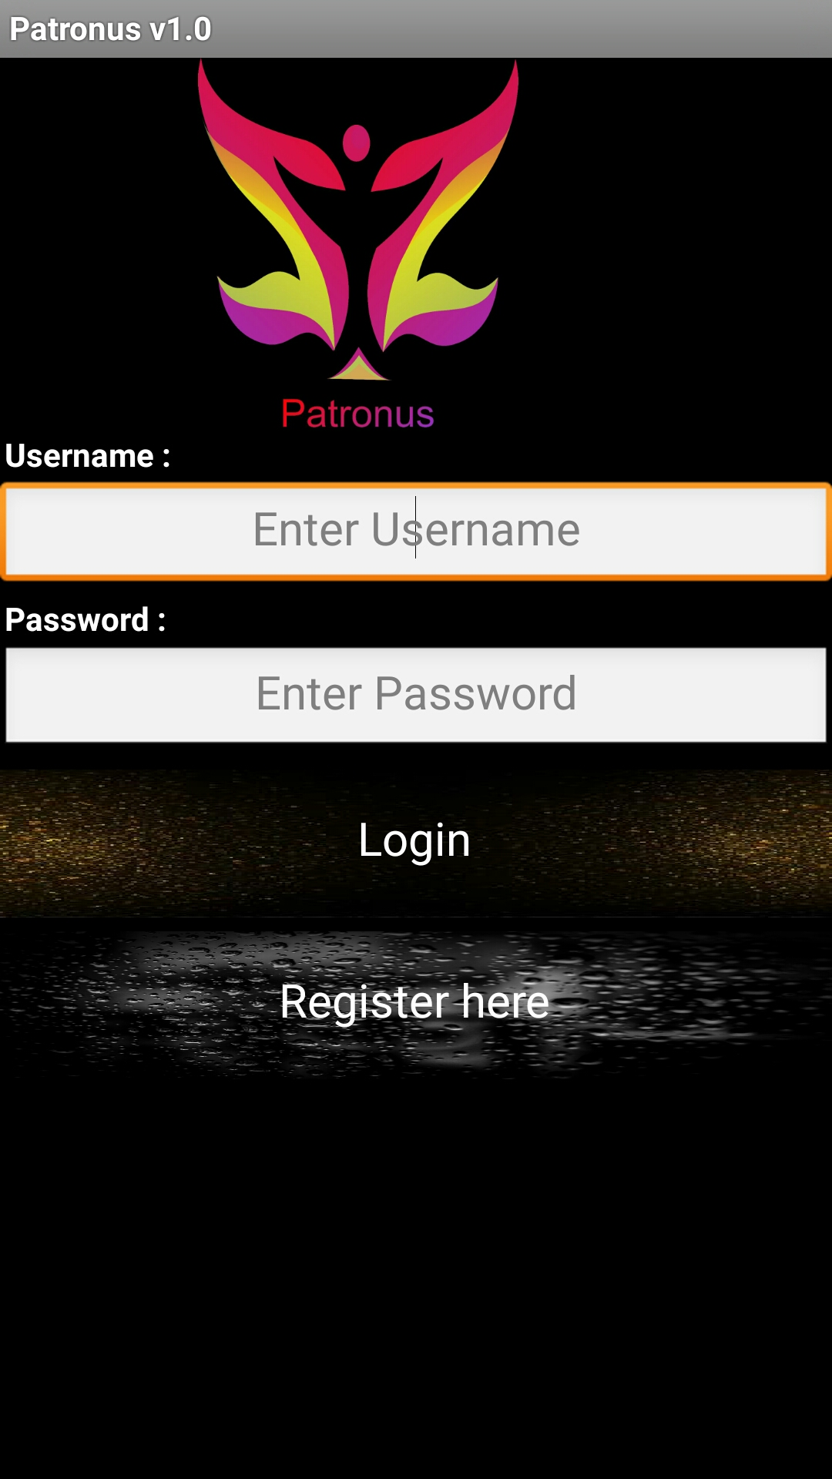

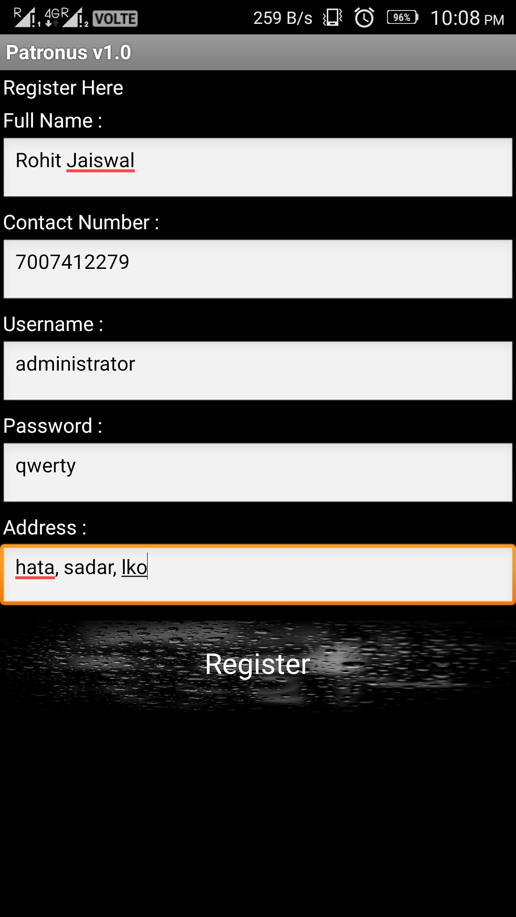

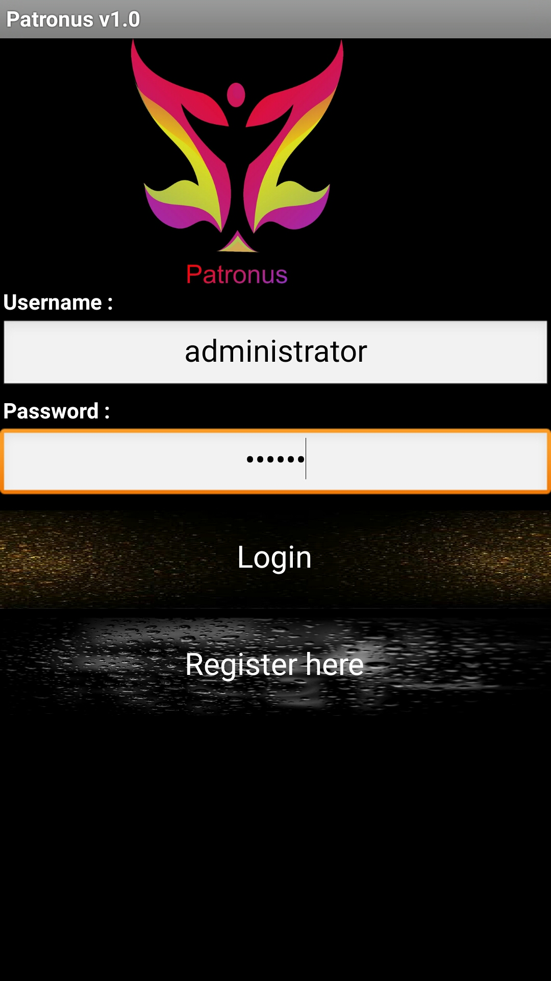

Testing & Debugging
Testing is a comprehensive organized effort to exercise all aspects of a software system for possible failure.

Code:

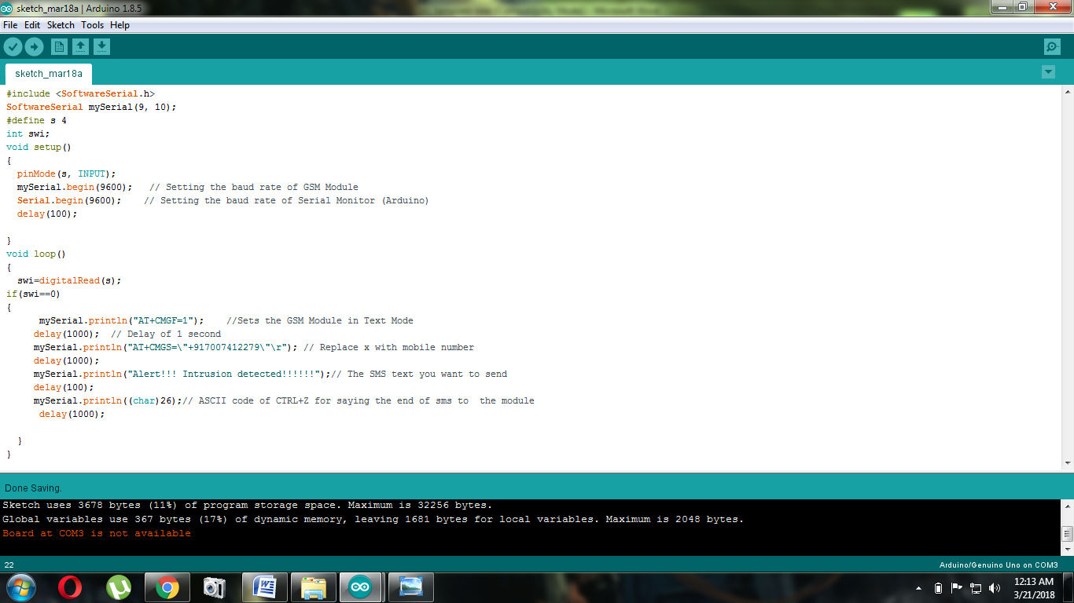
Problem:
Code was successfully uploaded but it was continuously notifying user about intrusion even if no intrusion was there.

Debugging is best when you don't have to do it, but knowing how to use a debugging tool can make the debugging process a lot less painful.

Code:

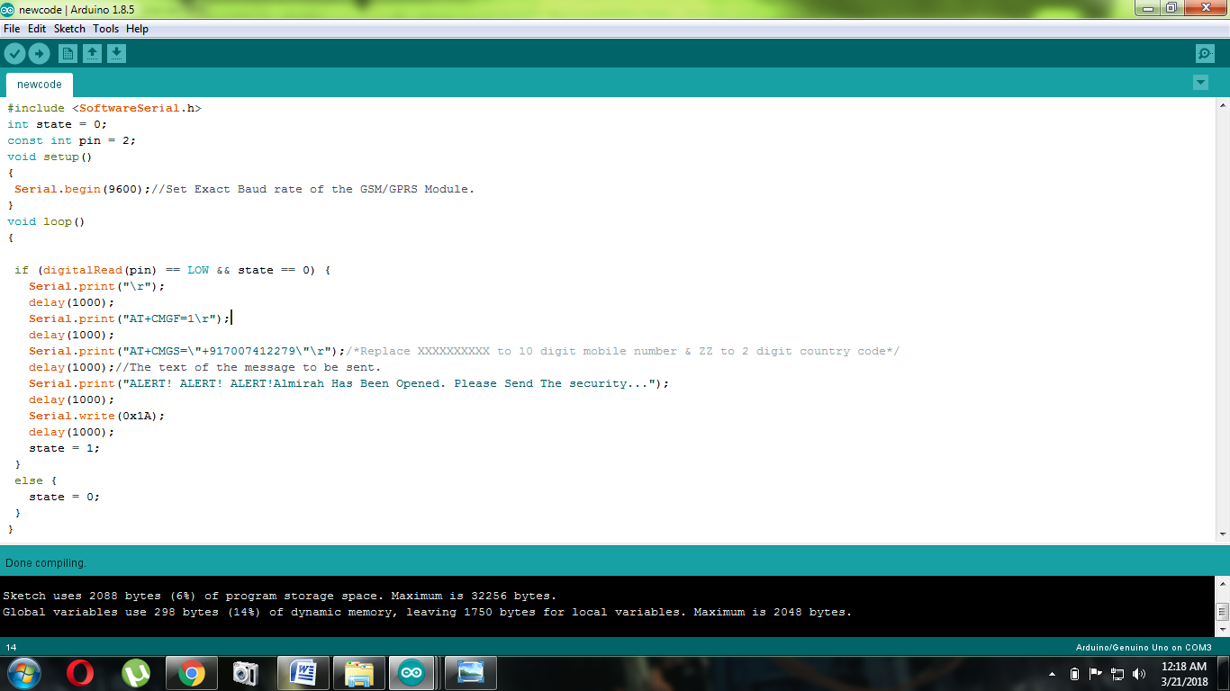
Solution to the above problem:

We added a new variable named status flag which is set to 0 initially. So if input is low with flag 0 the device notifies, else flag is again set to 0.

Other Nonfunctional Requirements

Performance Requirements
- Strong network
- Ample power supply
- Clear or minimum traffic jam
- Absence of static charge for safety

